United States

Of

America

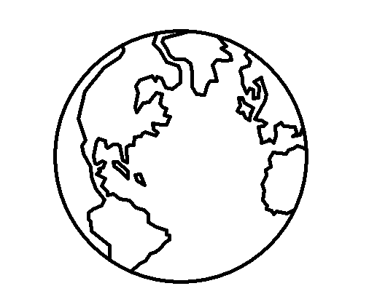

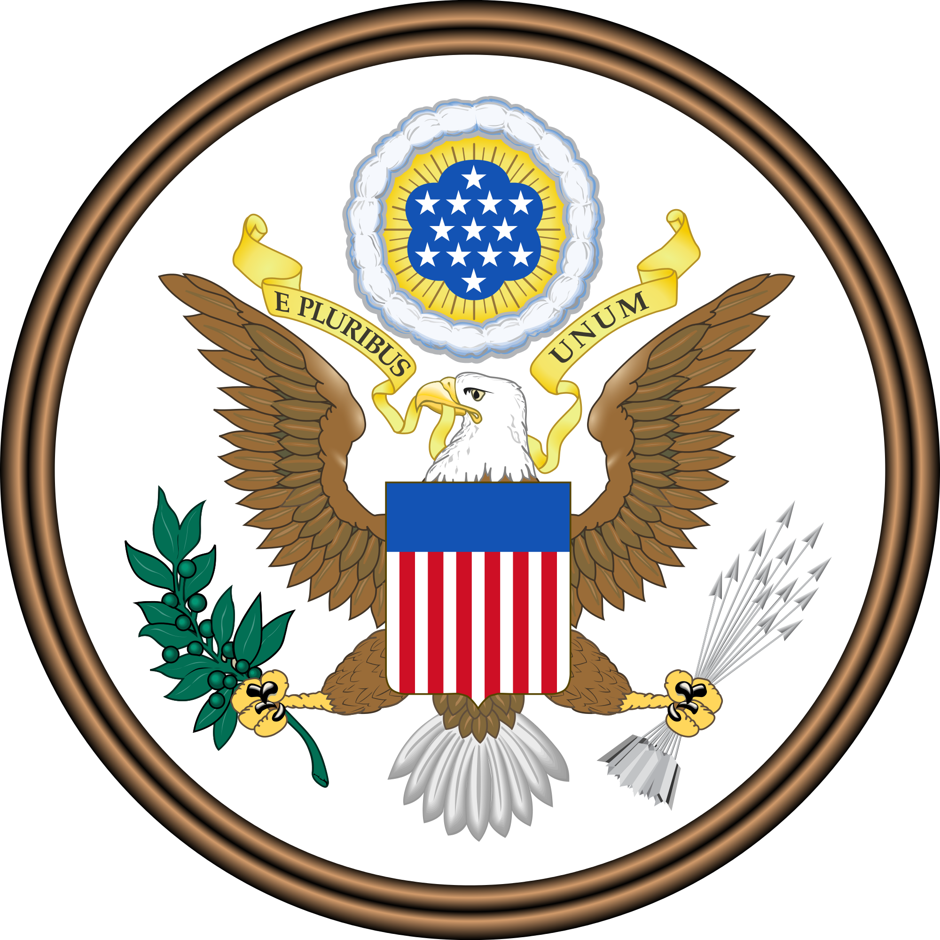

My Passport

DROP

PIC

HERE

Name

Country of Origin

Birthday

Place of Birth